IPO Analyzer

Author:Boyini Sharath Preetham

**Steps To start project;**

Git clone <git url>

* Enter into path and open vscode
* Install node modules using npm i
* Run the project using npm start

**Prerequisites**:

NPM

Node

VScode

**Features:**

Registration page

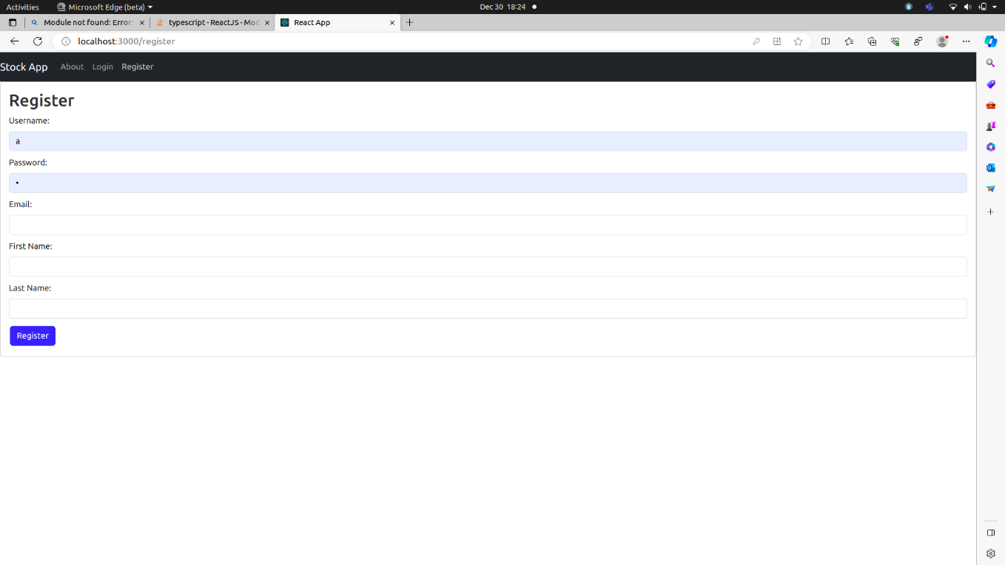

Login Page

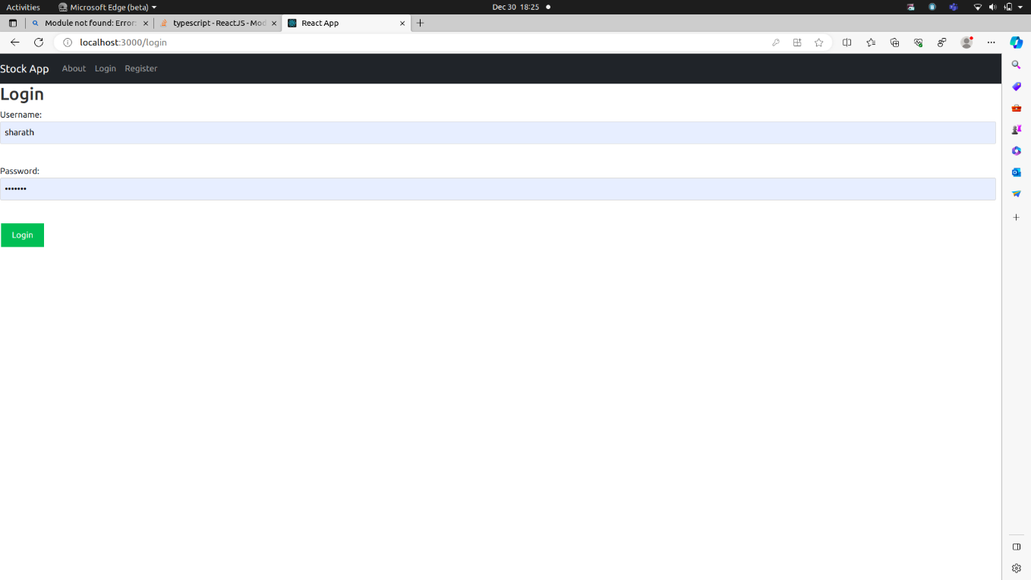

Login Validation

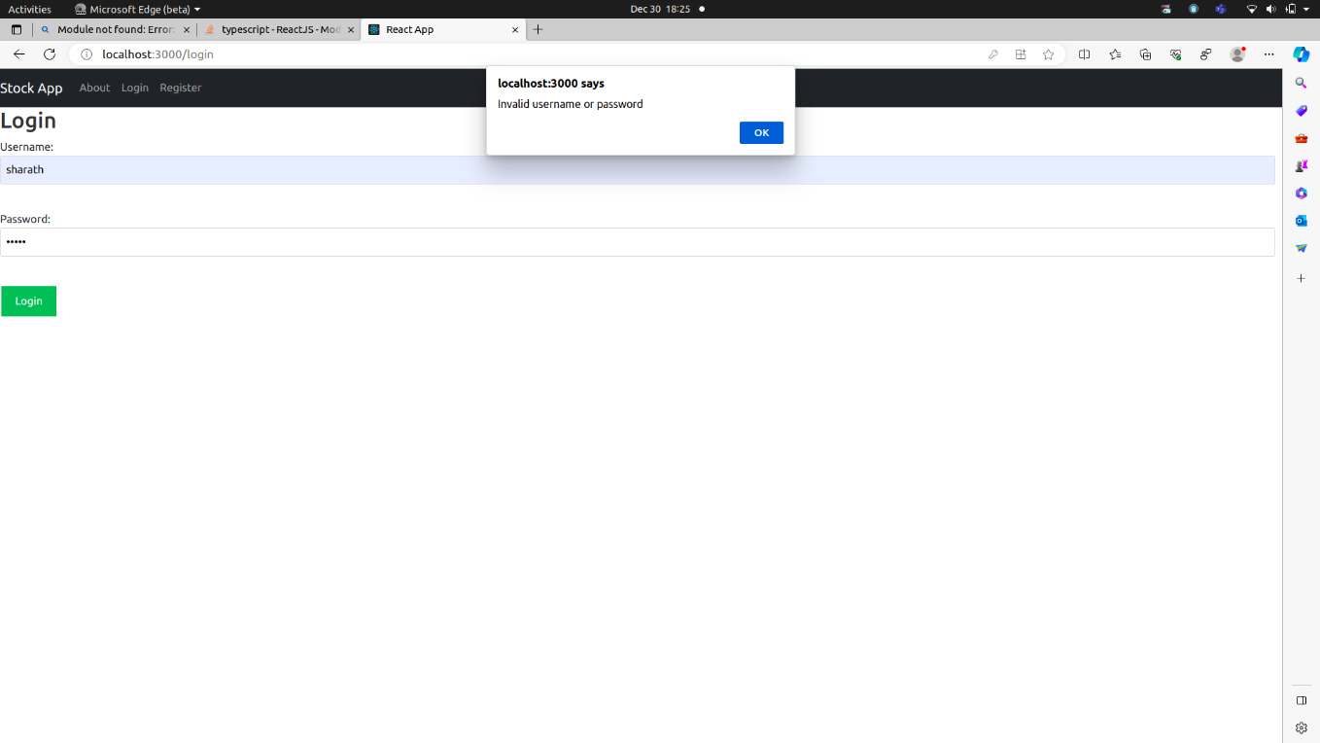

Login Successful

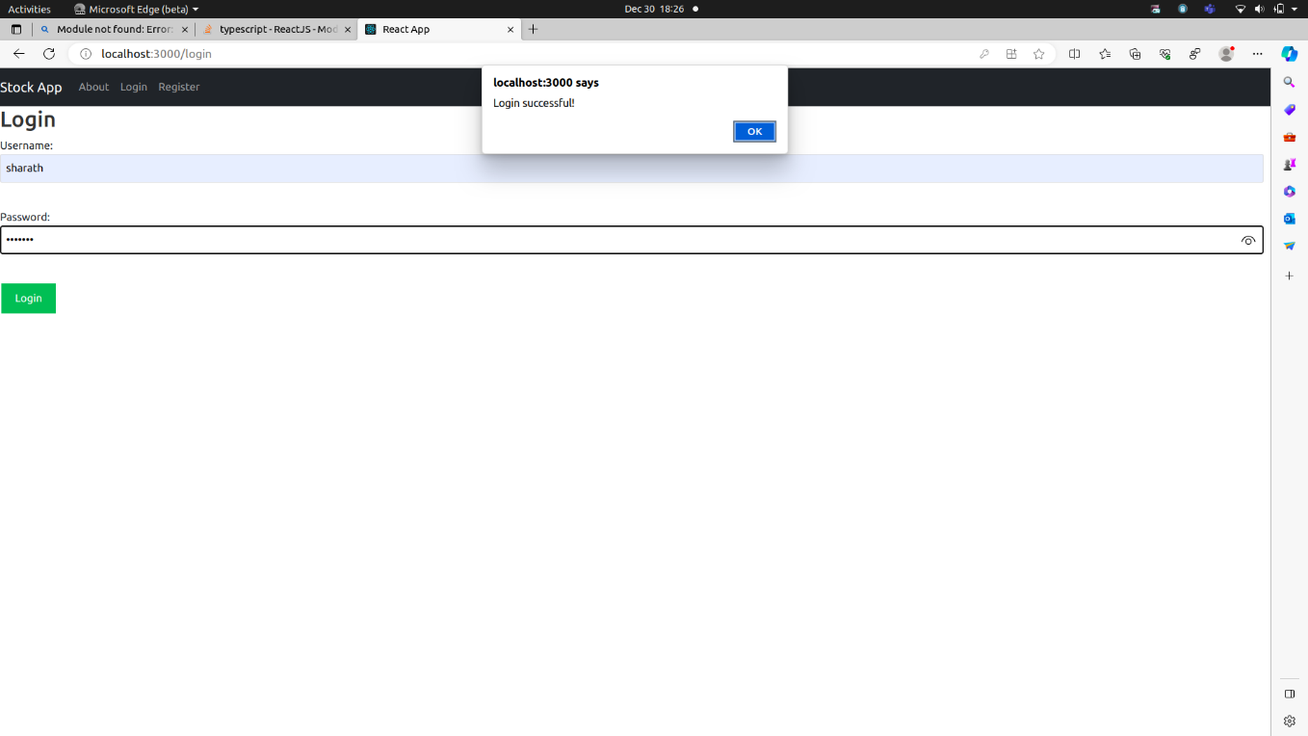

Dashboard

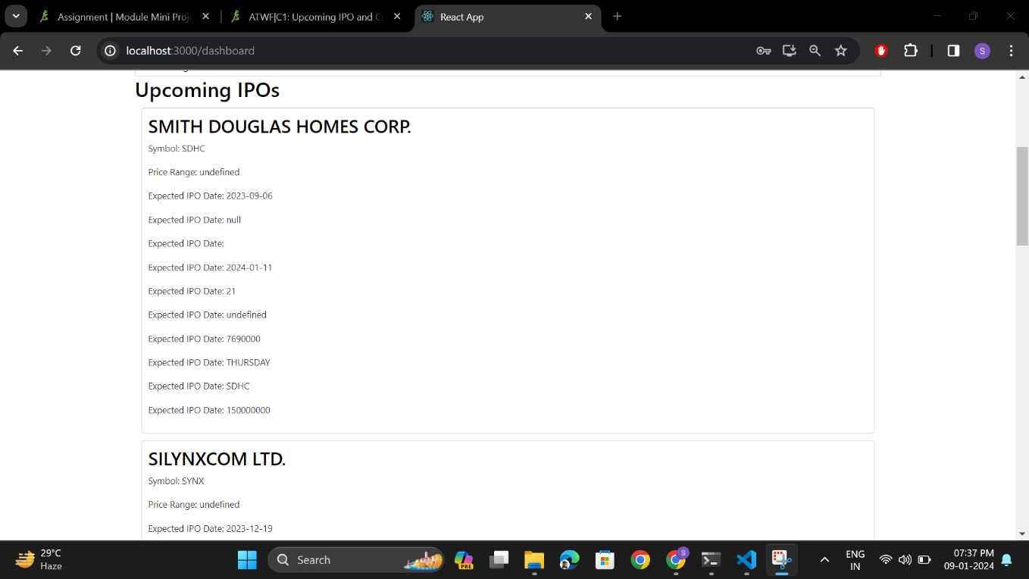

Dark Theme

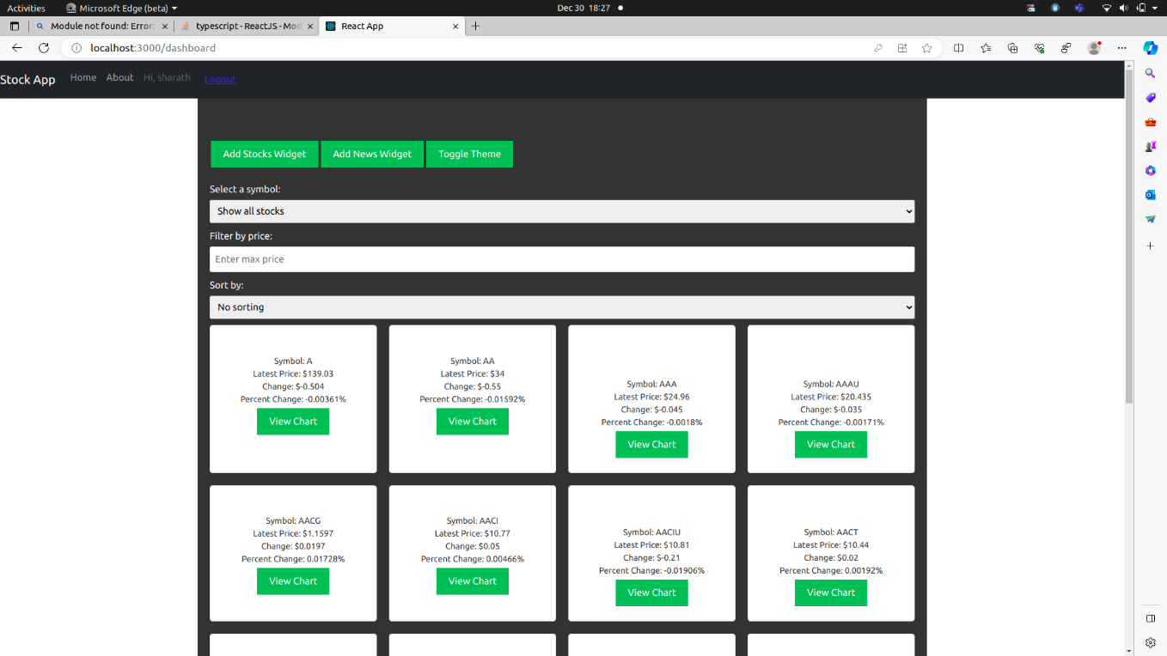

Add widgets

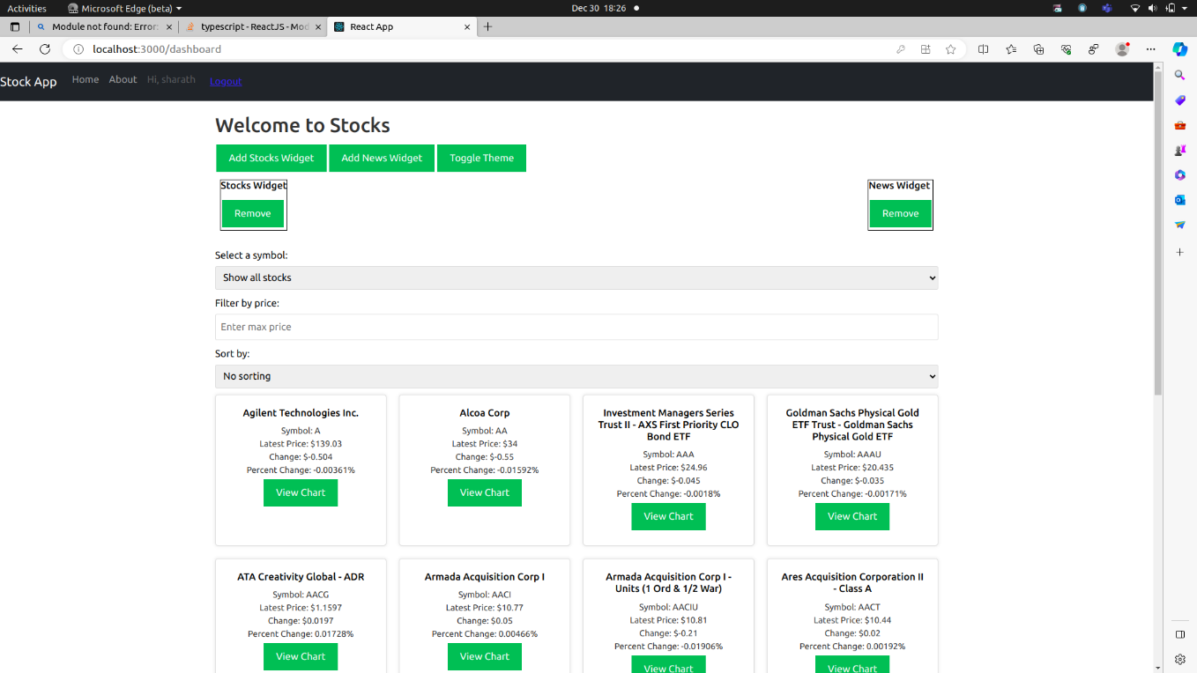

Currency exchange

